Nafiye Unal
ASSOC. PROF.

Research interests and expertise:  - Dr. Unal’s research interests focus on berry fruits.  - Soilless culture.  - In vitro techniques. | 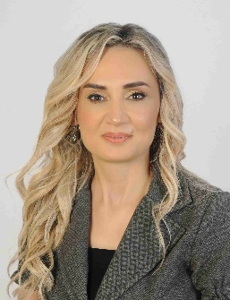
Biography:  - Associate Prof., Department of Horticulture, 2019-Continued.  - Assistant Prof., 2013-2019.  - Teaching Assistant, 2010-2013.  - Research Assistant, Department of Horticulture 1998-2009.  Education:  - Ph.D., Akdeniz University, Horticulture, 2009.  - M.Sc., Akdeniz University, Horticulture, 2000.  - B.S., Akdeniz University, Horticulture, 1997. | Department of Horticulture, University of Akdeniz.  Akdeniz University Dumlupınar Boulevard 07058 Campus  Antalya /Turkey  E-mail: nafiye@akdeniz.edu.tr  Telephone:  +90 242 227 4400/2469
Related Search
- Google Scholar
- Orcid ID
- Publons

