İlknur Polat
Assoc. Prof.

Research interests and expertise:

- Grape Genetics and Breeding
- Grape cultivation
- Agricultural Biotechnology

Biography:
- Assoc. Prof., Dep. of Horticulture, Akdeniz University, 2021 - Continued
- Assoc. Prof., Elmalı MYO, Akdeniz University, 2019 - Continued
- Agricultural Engineer, Batı Akdeniz Agricultural Research Institute 1997- 2019
- Research Assistant, Dep. of Horticulture, Akdeniz University,1993-1997.

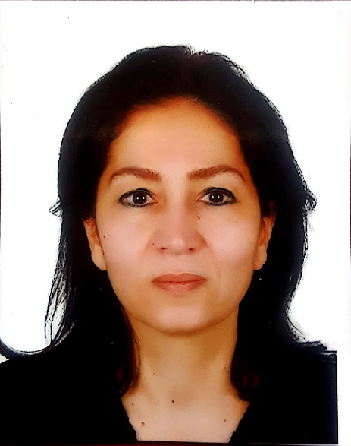

Department of Horticulture, University of Akdeniz.
Akdeniz University Dumlupınar Boulevard 07058 Campus
Antalya / Turkey
E-mail: ilknurpolat@akdeniz.edu.tr
Telephone: +90 242 3103709

Related Search

  - Google Scholar
  - OrcID

Education:
- Ph.D., Akdeniz University; Horticulture, 2004
- M.Sc., Akdeniz University; Horticulture, 1996
- B.Sc., Akdeniz University; Horticulture, 1992

